

# Batch: A3 Roll No.: 16010421075 Experiment No: 06

**Aim:** To create nested queries and view for the given database (Virtual lab).



**Resources needed:** PostgreSQL PgAdmin3



# not in:

This connective tests for absence of the set membership.

For example to select details of the books written by authors other than r.p.jain and d.perry use

select book_id, book_name,price from book where author not in(„r.p.jain‟, „d. perry‟,‟godse‟);

# all:

this keyword is basically used in set comparison query. It is used in association with relational operators.

“> all” corresponds to the phrase „greater than all‟.

For example to display details of the book that have price greater than all the books published in year 2000 use.

Select book_id, book_name, price from book where price >all (select price from book where pub_year=‟2000‟);

# any or some:

These keywords are used with relational operators in where clause of set comparison query. “=some” is identical to in and “<>some” is identical to not in.

“>any “ is nothing but „greater than at least one‟.

# exists and not exists:

exists is the test for non empty set. It is represented by an expression of the form ‘exists (select ……. From …….) ‘. Such expression evaluates to true only if the result evaluvating the subquery represented by the (select ……. From ……) is non empty.

for example to select names of the books for which order is placed use

select book_name from book where exists( select * from order where book_id=order.book_id);

(Autonomous College Affiliated to University of Mumbai)

**Views:**



Views are virtual tables created from already existing tables by selecting certain columns or certain rows. A view can be created from one or many tables. View allows to,

* Restrict access to the data such that a user can only see limited data instead of complete table.
* Summarize data from various tables which can be used to generate reports.

In PostgrSQL, Views are created using the CREATE VIEW statement given bellow.

CREATE [TEMP | TEMPORARY] VIEW view_name AS SELECT column1, column2..... FROM table_name WHERE [condition];

For example,

Consider COMPANY table having following records:

id | name | age | address | salary

----+-------+-----+------------+--------

1 | Paul | 32 | California | 20000

2 | Allen | 25 | Texas | 15000

3 | Teddy | 23 | Norway | 20000

4 | Mark | 25 | Rich-Mond | 65000

5 | David | 27 | Texas | 85000   
6 | Kim | 22 | South-Hall | 45000

7 | James | 24 | Houston | 10000

Following statement creates a view from COMPANY table.

CREATE VIEW COMPANY_VIEW AS SELECT ID, NAME, AGE FROM COMPANY;

Now, query can be written on COMPANY_VIEW in similar way as that of an actual table, as shown below,

SELECT * FROM COMPANY_VIEW;

This would produce the following result:

View can be dropped using “DROP VIEW” statement.

_____________________________________________________________________________

**Procedure / Approach /Algorithm / Activity Diagram:**

* 1. Refer different syntax given in theory section and formulate queries consisting of nested sub queries, in , not in, as, group by, having etc clauses and different set operations for your database.
  2. Create views from existing tables

Execute SELECT,UPDATE,INSERT statements on views and original table.

**___________________________________________________________________________**

**Results: (Program printout with output / Document printout as per the format)**

**create view AIRPORT1 as select airport_name from AIRPORT where city = 'Mumbai'**

**select*from AIRPORT1**

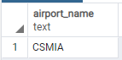

**create view BOOKS1 as select * from BOOKS where passenger_id>10001**

**select * from BOOKS1**

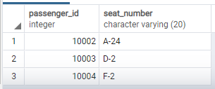

**SELECT * FROM Employee WHERE Employee_Name IN ('Keyur', 'Fatma Sheldon', 'Krishiv');**



**SELECT * FROM Employee WHERE Employee_Name NOT IN ('Keyur', 'Fatma Sheldon', 'Krishiv');**

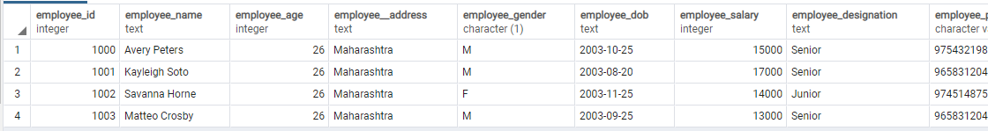

**Select employee_salary from Employee where employee_salary >all (select employee_salary from Employee where employee_id>1001);**

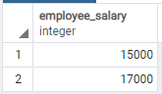

___________________________________________________________________________

**Questions:**

* 1. Explain what are the disadvantages using view on update function.

1. 1. When a table is dropped, associated view become irrelevant.
2. 2. Since the view is created when a query
3. requesting data from view is triggered,
4. its a bit slow.
5. 3. When views are created for large tables,
6. it occupies more memory

2Can we use where clause with group by clause? Justify your answer

The GROUP BY Clause is utilized in SQL with the SELECT statement to organize similar data into groups. It combines the multiple records in single or more columns using some functions. Generally, these functions are aggregate functions such as min(),max(),avg(), count(), and sum() to combine into single or multiple columns. It uses the **split-apply-combine** strategy for data analysis.

3 Can we use having and group by clause without Aggregate functions? Justify your answer

**No,we can’t use having and group by clause without aggregate functions. This is because in case of group by it would group the data and display only one set of data from each group which it would select at random.For example,I have a table emp with following structure and data:**

**___________________________________________________________________________**

**Outcomes:**

Illustrate the concept of security, query processing and normalization for relational database

**_____________________________________________________________________________**

**Conclusion: (Conclusion to be based on the objectives and outcomes achieved)**

This experiment helped in understanding what view is and how can one use view in database.



**Grade: AA / AB / BB / BC / CC / CD /DD**

**Signature of faculty in-charge with date**

**___________________________________________________________________________**

**References:**

**Books/ Journals/ Websites:**

1. Korth, Slberchatz,Sudarshan, :”Database System Concepts”, 6th Edition, McGraw –

Hill

1. Elmasri and Navathe, “ Fundamentals of Database Systems”, 5thEdition, PEARSON

Education.